**DAILY ONLINE ACTIVITIES SUMMARY**

|  |  |  |  |  |  |  |  |  |
| --- | --- | --- | --- | --- | --- | --- | --- | --- |
| **Date:** | **23/06/2020** | | | | | **Name:** | **Anjali Manohar Prabhu** | |
| **Sem & Sec** | **4th Sem Section - ‘A’** | | | | | **USN:** | **4AL18CS007** | |
| **Online Test Summary** | | | | | | | | |
| **Subject** | | **N/A** | | | | | | |
| **Max. Marks** | | **N/A** | | **Score** | | | **N/A** | |
| **Certification Course Summary** | | | | | | | | |
| **Course** | **IoT WEBMINAR** | | | | | | | |
| **Certificate Provider** | | | 1. **Great Learning Academy** | | **Duration** | | | **11.0hrs** |
| **Coding Challenges** | | | | | | | | |
| **Problem Statement:**   1. Write a java program to find modular exponential | | | | | | | | |
| **Status: Executed** | | | | | | | | |
| **Uploaded the report in Github** | | | | | **YES** | | | |
| **If yes Repository name** | | | | | [**https://github.com/vinisharen/lockdown-coding**](https://github.com/vinisharen/lockdown-coding) | | | |
| **Uploaded the report in slack** | | | | | **YES** | | | |

Online Test Details: N/A

Certification Course Details: There was a WEBMINAR session on IoT topic based on senors.counducted by “**PROF SUSHANT M”.** on google meet. A quiz was conducted on the particular topic.The duration of the quiz was 20 mins(4 pm to 4:20 pm).The questions were of MCQ type.

**SNAPSHOT:**

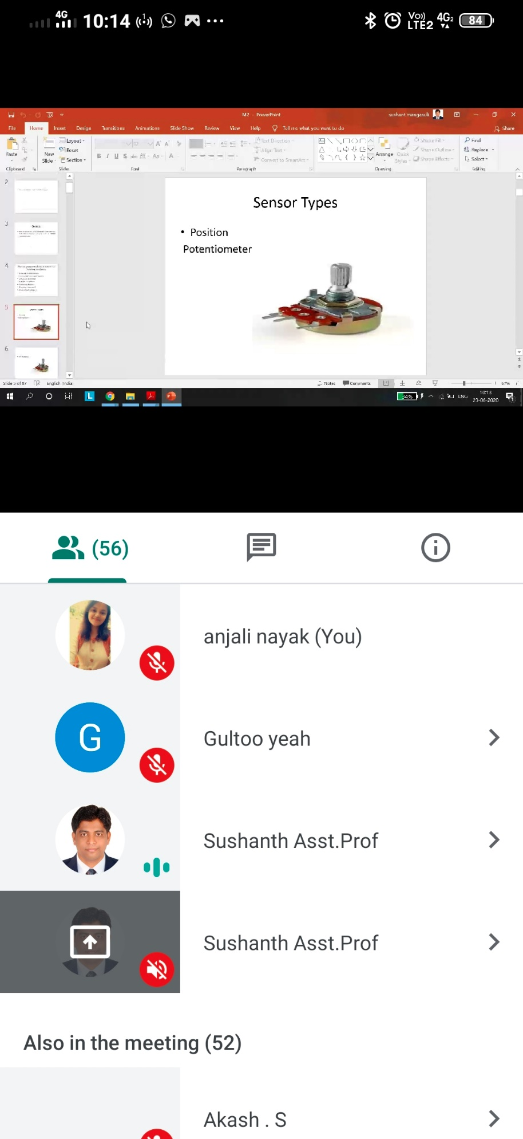

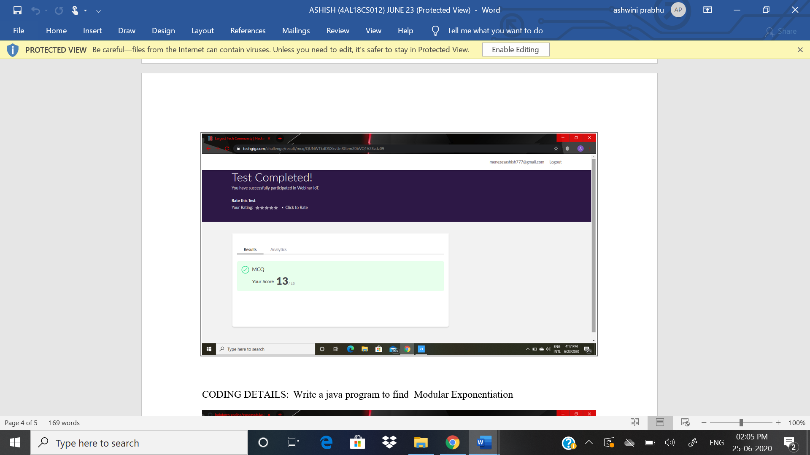

ONLINE CODING DETAILS:

PROBLEM 1: Write a JAVA program to find modular exponential.

SNAPSHOT:

